- Create a database called “CricketerStatsDB”.

SQL Command
Create Schema CricketerStatsDB;
use cricketerstatsdb;

- Create a table titled “Players” with the following constraints.
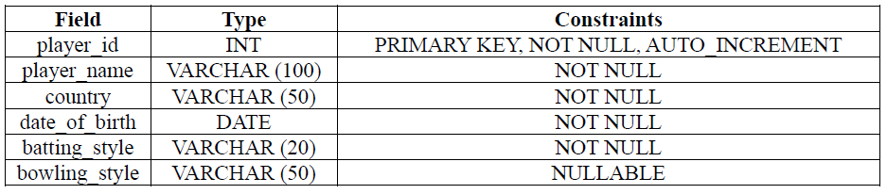

SQL Command
create table Players(
player_id INT PRIMARY KEY NOT NULL AUTO_INCREMENT,
player_name VARCHAR (100) NOT NULL,
country VARCHAR (50) NOT NULL,
date_of_birth DATE NOT NULL,
batting_style VARCHAR (20) NOT NULL,
bowling_style VARCHAR (50) NULL
);

- Create a table titled “Matches” with the following constraints.
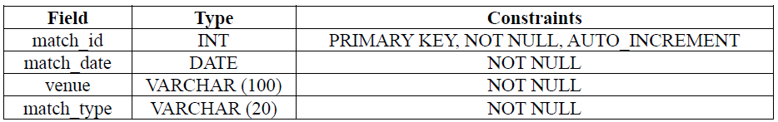

SQL Command
create table Matches(
match_id INT PRIMARY KEY NOT NULL AUTO_INCREMENT,
match_date DATE NOT NULL,
venue VARCHAR (100) NOT NULL,
match_type VARCHAR(20) NOT NULL
);
- Create a table titled “Performances” with the following constraints.
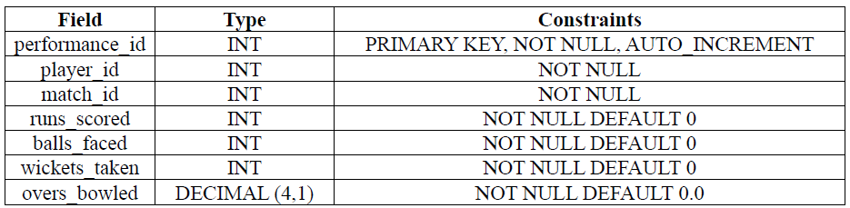

SQL Command
create table Performances(
performance_id INT PRIMARY KEY NOT NULL AUTO_INCREMENT,
player_id INT NOT NULL,
match_id INT NOT NULL,
runs_scored INT NOT NULL DEFAULT 0,
balls_faced INT NOT NULL DEFAULT 0,
wickets_taken INT NOT NULL DEFAULT 0,
overs_bowled DECIMAL (4,1) NOT NULL DEFAULT 0
);

- Populate the table “Players” with the following data
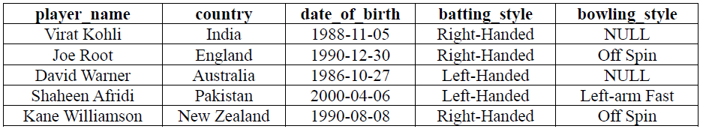

SQL Command
INSERT INTO Players (player_name, country, date_of_birth, batting_style, bowling_style)
VALUES
('Virat Kohli', 'India', '1988-11-05', 'Right-Handed', NULL),
('Joe Root', 'England', '1990-12-30', 'Right-Handed', 'Off Spin'),
('David Warner', 'Australia', '1986-10-27', 'Left-Handed', NULL),
('Shaheen Afridi', 'Pakistan', '2000-04-06', 'Left-Handed', 'Left-arm Fast'),
('Kane Williamson', 'New Zealand', '1990-08-08', 'Right-Handed', 'Off Spin');

- Populate the table “Matches” with the following data.
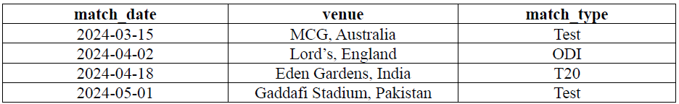

SQL Command
INSERT INTO Matches (match_date, venue, match_type)
VALUES
('2024-03-15', 'MCG, Australia', 'Test'),
('2024-04-02', 'Lord''s, England', 'ODI'),
('2024-04-18', 'Eden Gardens, India', 'T20'),
('2024-05-01', 'Gaddafi Stadium, Pakistan', 'Test');

- Populate the table “Performances” with the following data.
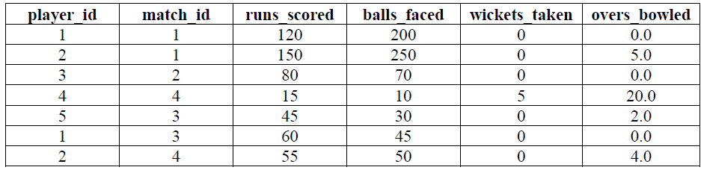

SQL Command
INSERT INTO Performances (player_id, match_id, runs_scored, balls_faced, wickets_taken, overs_bowled)
VALUES
(1, 1, 120, 200, 0, 0.0),
(2, 1, 150, 250, 0, 5.0),
(3, 2, 80, 70, 0, 0.0),
(4, 4, 15, 10, 5, 20.0),
(5, 3, 45, 30, 0, 2.0),
(1, 3, 60, 45, 0, 0.0),
(2, 4, 55, 50, 0, 4.0);

Query-01:
Display all players.
SQL Command
select *
from players
Output:
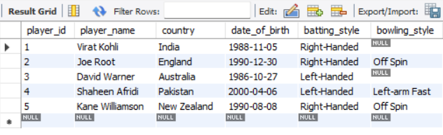

Query-02:
List all match venues and types.
SQL Command
select venue, match_type
from matches
Output:
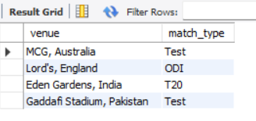

Query-03:
Find players born after 1990.
SQL Command
select player_name, country, date_of_birth
from players
where year(date_of_birth)>1990;
Output:
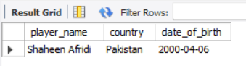
Query-04:
Show performances where runs scored > 50.
SQL Command
select player_id,match_id,runs_scored
from performances
where runs_scored>50;
Output:
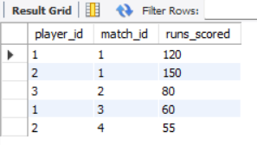

Query-05:
Find the number of matches played at each venue.
SQL Command
select venue, count(venue) as match_count
from matches
group by venue;
Output:
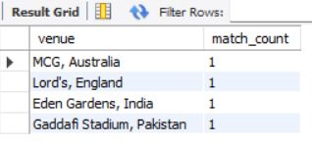

Query-06:
List players with their total runs scored.
SQL Command
select player_name, sum(runs_scored) as total_runs
from players natural join performances
group by player_id
Output:
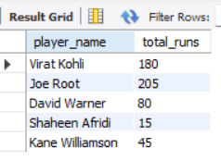

Query-07:
Find players who scored more than 100 in any match.
SQL Command
select player_name, runs_scored
from players as p natural join performances as pf
where pf.runs_scored>100 and (p.player_id=pf.player_id);
Output:
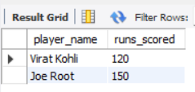

Query-08:
Find average balls faced per player.
SQL Command
select player_name, avg(balls_faced) as avg_balls
from players as p natural join performances as pf
group by player_id
Output:
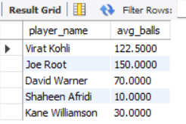

Query-09:
Find the top wicket-taker player.
SQL Command
select player_name, wickets_taken
from players natural join performances
where wickets_taken=
(
select max(wickets_taken)
from performances
);
Output:
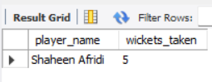

Query-10:
Find the top wicket-taker player.
SQL Command
select match_id,venue, sum(runs_scored) as total_runs, sum(wickets_taken) as total_wickets
from matches natural join performances
group by match_id
order by match_id asc;
Output:
